 | Journey Middle School  217 Celtic Drive, Madison, Alabama 35758  7th Grade Accelerated Math  Mrs. Bain  2024-2025

Teacher Contact Information | Email: lmbain@madisoncity.k12.al.us  Classroom Phone: 256-774-4695
Classroom Digital Platforms | Webpage Link: https://www.madisoncity.k12.al.us/site/Default.aspx?PageID=9217  Schoology Link:  A Block (Accelerated Math 7): https://madisoncity.schoology.com/course/7360358656/materials
Textbook Information | McGraw Hill Alabama Reveal Math: https://my.mheducation.com/  ***The textbook can be accessed through Schoology by clicking on the 4 boxes in the top right corner then clicking on the red McGraw Hill icon.  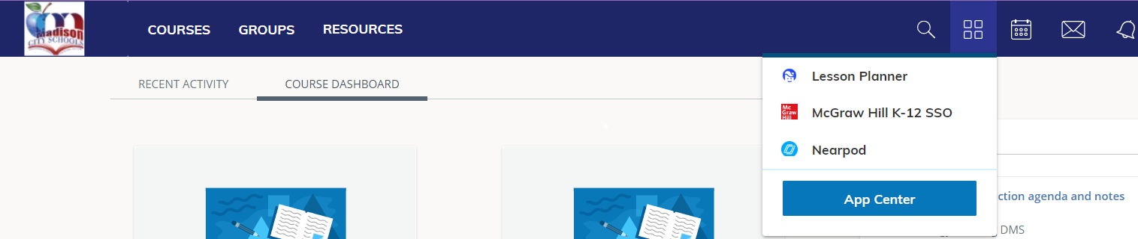
Course Description | The Grade 7 Accelerated course has been carefully aligned and designed for middle school students who show particular motivation and interest in mathematics. In Grade 7 Accelerated, the content is organized into five Alabama Content Areas: Proportional Reasoning; Number Systems and Operations; Algebra and Functions; Data Analysis, Statistics, and Probability; and Geometry and Measurement.  Current Alabama Math Course of Study
Course Objectives | The objective of this course is to successfully master the skills outlined in the Alabama Accelerated Math 7 Course of Study. Students successfully completing this course will be prepared for Accelerated Math 8.
Course Outline | Unit 1 (Module 3): Operations with Integers and Rational Numbers  Unit 2 (Module 1): Proportional Relationships  Unit 3 (Module 2): Solve Percent Problems  Unit 4 (Module 6): Algebraic Expressions  Unit 5 (Module 7): Equations and Inequalities  Unit 6 (Module 9): Probability  Unit 7 (Module 10): Sampling and Statistics  Unit 8 (Module 11): Geometric Figures  Unit 9 (Module 12): Measure 2D and 3D Figures  Unit 10 (Module 4): Exponents and Scientific Notation  Unit 11 (Module 5): Real Numbers  Unit 12 (Module 8): Linear Relationships and Slope  Unit 13 (Module 13): Transformations  Unit 14 (Module AL8): Linear Functions  *This is subject to change.
Classroom Expectations | - Enter class with a positive mindset for learning.  - Be in your seat when the tardy bell rings.  - Bring all books, homework, and supplies with you.  - Treat others as you want to be treated.  - Food is not allowed in classrooms.  - Gum is not allowed at school at any time.  - Behave in a manner conducive to learning for all.  - Show respect for yourself and others at all times.  - Follow all classroom procedures.  - Follow all rules listed in your JMS Handbook and Madison City Schools Code of Conduct.
Progressive Discipline  (JMS Policy) | All progressive discipline will correspond with the Madison City Schools Code of Conduct regarding Class I and II offenses. Class III offenses are a direct office referral.  ● Warning  ● Conference with student with parent notification  ● Parent Contact  ● Detention  ● Referral to administration for repeat Class I violations and initial Class II and  III offenses---Consequences determined to be reasonable and appropriate  by the school administration.
Cell Phone Policy | Students are welcome to bring personal electronic devices to school. Students will not be allowed to use cell phones during class. Cell phones may be used during class transitions and lunch. All cell phones must be placed in student’s backpacks. Also, remember that the student is responsible for locking and securing personal devices. JMS is not responsible for lost, stolen, or damaged cell phones and other electronic devices. Students should ensure personal devices are always in a safe and secure location. Additionally, students may not use their devices to do anything inappropriate that would disrupt the learning environment at Journey Middle School.
Grading Policy  (MCS Policy) | Middle School  60% = Assessments (Tests, Essays, Projects)  40% = Daily Grades (Quizzes, Homework, Classwork, and Participation)  All work/steps MUST be shown to ensure full credit on any assignment. Without documentation showing how the problems were solved, credit may not be given, even if answers are correct.
Late Work Policy | Students present in class on the day of instruction are expected to turn in all in-class and out-of-class assignments on time. Students are required to turn in work ON TIME. For late submissions:  ● Late submissions will be accepted up to 3 days following the due date but an automatic 20% will be deducted from points earned.  ● After 3 days, no late work will be accepted and the zero will stand.
Make-up Work/Test Policy | Before inserting your Make-Up Policy, please ensure it meets the minimum requirements according to the Madison City Code of Conduct on p. 12.
Technology | Student laptops should not be hard-wired to the network or have print capabilities. Use of discs, flash drives, jump drives, or other USB devices will not be allowed on Madison City computers. Neither the teacher nor the school is responsible for broken, stolen, or lost laptops. Laptops and other electronic devices will be used at the individual discretion of the teacher.
Accommodations | Requests for accommodations for this course or any school event are welcomed from students and parents.
My Planning | Block B
Materials & Supplies | Below is a list of supplies your child will need for seventh grade math. Please make every effort  to be sure he/she has needed supplies for class.  1) 1.5”-2” 3 Ring Binder with dividers and a Composition Notebook  2) Loose-leaf paper  3) Graph Paper  4) Scientific Calculator (TI-30XS) - Link for efficient and affordable options  5) Pencils (sharpened with an eraser) needed daily  6) Glue sticks  7) Scissors  8) Binder pencil pouch
Homework | Homework will be assigned periodically in Accelerated Math 7. Students will be responsible for completing their homework online or on paper on or before its due date.
Parent & Student Acknowledgment Form | Click here to sign the acknowledgment form.

